PHASE 8

DEPLOYMENT, DOCUMENTATION & FINAL SUBMISSION
Objective:
To prepare the AI BlogNest project for deployment, complete the project documentation and prepare the required links for final submission.
Deployment Activities:
- Prepared the project for online deployment.
- Configured the project for Git version control.
- Initialized a Git repository for the project.
- Created and configured the .gitignore file.
- Excluded sensitive files such as .env.
- Excluded node_modules from Git tracking.
- Prepared the project for uploading to GitHub.
Documentation Activities:
- Prepared the complete phase-wise project documentation.
- Documented the project objectives and requirements.
- Documented the system architecture and database design.
- Documented backend, AI integration and frontend development.
- Documented testing and validation activities.
Final Submission Requirements:
- GitHub Link: Repository containing the project source code and documentation.
- Demo Link: Publicly accessible URL of the deployed AI BlogNest application.
- The .env file and Gemini API key should not be uploaded to GitHub.
- localhost:5000 should be used only for local testing, not as the public Demo Link.
Expected Output:
A complete project with documentation, GitHub repository and a public Demo Link ready for final project submission.
Current Status:
Documentation and Git preparation are completed. Public deployment and final SkillWallet submission are pending.
Phase Status:
Finalization Stage.
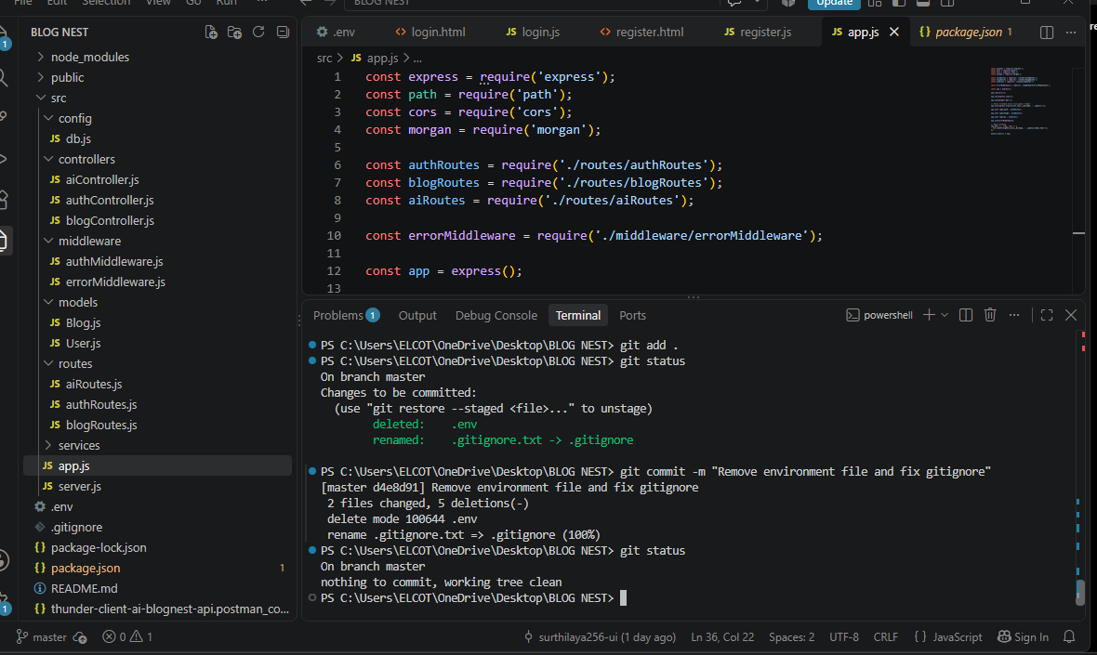
Figure 8.1: Git Repository Status of AI BlogNest Project

